<INTRODUCTION TO DATA MANAGEMENT>
PROJECT REPORT
(Project Semester January-April 2025)

(HR ANALYTICS DASHBOARD)

Submitted by
Colin Varghese

Registration No 12315719
Roll number: 19

Section K23GS
Course Code INT217

Under the Guidance of

Baljinder Kaur

Discipline of CSE/IT

Lovely School of Computer Science & Engineering

Lovely Professional University, Phagwara

CERTIFICATE

This is to certify that Colin Varghese bearing Registration no.12315719 has completed .INT217 project titled, “Dashboard” under my guidance and supervision. To the best of my knowledge, the present work is the result of his/her original development, effort and study.

Signature and Name of the Supervisor
Designation of the Supervisor
School of Computer science & Engineering
Lovely Professional University
Phagwara, Punjab.

Date: 13 April 2025

DECLARATION

I am Colin Varghese, student of Computer science & engineering under CSE/IT Discipline at, Lovely Professional University, Punjab, hereby declare that all the information furnished in this project report is based on my own intensive work and is genuine.

Date: 13 April 2025 Signature
Registration No. 12315719 Name Colin Varghese

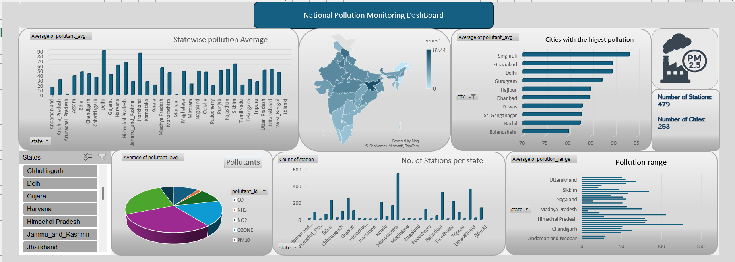
Objectives
- Statewise pollution average
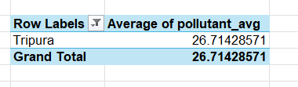
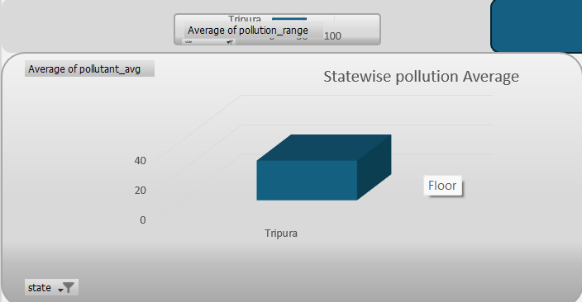

2 Quantity of Pollutants in different states
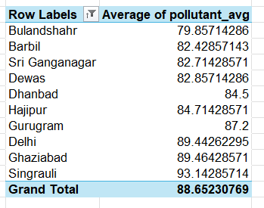
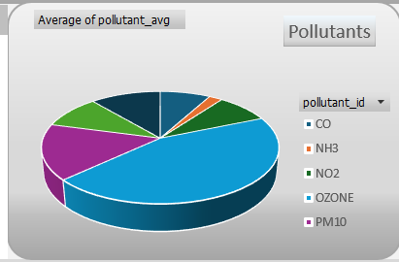

3)Ponution Range

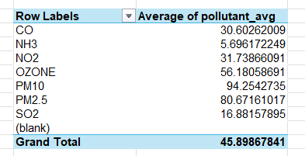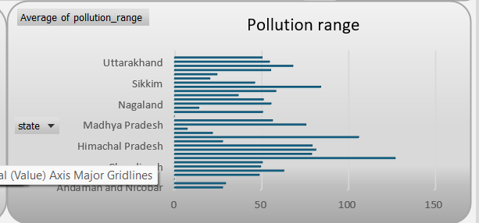

4) No of Station per states
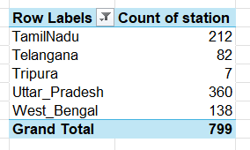
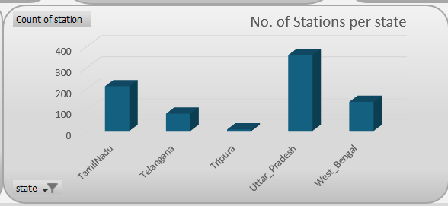

5) Cities with highest pollution
